SIMATS ENGINEERING
ASSESSMENT TOOL 1
Name: J Jaslin Jeba Thurai
Reg No: 192321175
Course Name: Database Management Systems
Course Code: CSA0501
Total Marks: 50
Assessment Tool Weightage: 30%
Activity Tool: Short Answer Text (High)
Course Outcome Covered (CO1):
Analyze DBMS architecture, different data models, schema types, and design ER/EER diagrams and relational schemas for case-based scenarios by identifying entities and relationships. (BL1, BL2)

Questions
Total Marks: 50
Q.No | Question | Bloom’s Level | Marks
1 | UPS Product Tracking Information System  UPS prides itself on having up-to-date information on the processing and current location of each shipped item. To do this, UPS relies on a company-wide information system. Shipped items are the heart of the UPS product tracking information system. Shipped items can be characterized by item number (unique), weight, dimensions, insurance amount, destination, and final delivery date. Shipped items are received into the UPS system at a single retail center. Retail centers are characterized by their type, uniqueID, and address. Shipped items make their way to their destination via one or more standard UPS transportation events (i.e., flights, truck deliveries). These transportation events are characterized by a unique scheduleNumber, a type (e.g., flight, truck), and a deliveryRoute. Create an Entity Relationship diagram that captures this information about the UPS system. | BL1 – Remember | 5
2 | Course Management System  Consider a university database for the scheduling of classrooms for final exams. This database could be modeled as the single entity set exam, with attributes course-name, section-number, room-number, and time. Alternatively, one or more additional entity sets could be defined, along with relationship sets to replace some of the attributes of the exam entity set, as:  • course with attributes name, department, and c-number  • section with attributes s-number and enrollment, and dependent as a weak entity set on course  • room with attributes r-number, capacity, and building  Show an E-R diagram illustrating the use of all three additional entity sets listed. | BL2 – Understand | 5
3 | University Registrar’s Office Management System  A university registrar’s office maintains data about the following entities:  (a) courses, including number, title, credits, syllabus, and prerequisites;  (b) course offerings, including course number, year, semester, section number, instructor(s), timings, and classroom;  (c) students, including student-id, name, and program;  (d) instructors, including identification number, name, department, and title.  (e) Further, the enrollment of students in courses and grades awarded to students in each course they are enrolled for must be appropriately modeled.  Construct an E-R diagram for the registrar’s office. | BL2 – Understand | 5
4 | Hospital Management System  Construct an E-R diagram for a hospital with a set of patients and a set of medical doctors.  Associate with each patient a log of the various tests and examinations conducted. Construct appropriate tables for the above ER Diagram:  Patient(SS#, name, insurance)  Physician (name, specialization)  Test-log( SS#, test-name, date, time)  Doctor-patient (physician-name, SS#)  Patient-history(SS#, test-name, date) | BL2 – Understand | 5
5 | Company Project Management System  Construct an ER Diagram for Company having following details:  Company organized into DEPARTMENT. Each department has unique name and a particular employee who manages the department. Start date for the manager is recorded. Department may have several locations.  • A department controls a number of PROJECT. Projects have a unique name, number and a single location.  • Company’s EMPLOYEE name, ssno, address, salary, sex and birth date are recorded. An employee is assigned to one department, but may work for several projects (not necessarily controlled by dept). Number of hours/week an employee works on each project is recorded; The immediate supervisor for the employee.  • Employee’s DEPENDENT are tracked for health insurance purposes (dependentname, birthdate, relationship to employee). | BL2 – Understand | 5
6 | Explain schema and instance with examples. Distinguish between logical schema, physical schema, and view schema. | BL1 – Remember | 5
7 | Identify the entities, attributes, and relationships for a Bank Management System and construct its ER diagram. | BL2 – Understand | 5
8 | Explain the Extended ER (EER) model. Describe the concepts of generalization, specialization, and aggregation. | BL2 – Understand | 5
9 | Design an EER diagram for a Hospital Management System incorporating inheritance and weak entities. | BL2 – Understand | 5
10 | Explain the role of a DBA (Database Administrator) and the responsibilities associated with the position. | BL1 – Remember | 5

Code of Conduct:
I ____________________ (Name / Reg No) certify that this submission is my original work and that I have adhered to the guidelines specified for this assessment. I understand that any violation of academic integrity rules will result in disciplinary action.
Signature of the student:

Rubrics for Calculation
Criteria | Weightage | Level 4 (Exemplary) | Level 3 (Proficient) | Level 2 (Developing) | Level 1 (Beginning)
Concept Identification | 30% | Demonstrates clear and complete understanding of the concept | Good understanding with minor gaps | Basic understanding with some misconceptions | Poor or incorrect understanding
Linkages | 25% | Completely correct answer with no errors | Mostly correct with minor errors | Partially correct with noticeable errors | Incorrect or irrelevant answer
Organization | 20% | Correctly applies concepts to solve the question/problem | Applies concepts with minor mistakes | Limited or partially correct application | No or incorrect application
Integration of Literature | 15% | Covers all required parts of the question | Covers most parts with minor omissions | Covers only some parts | Incomplete or missing response
Clarity | 10% | Clear, concise, and well-organized answer | Understandable with minor issues | Somewhat unclear or poorly structured | Difficult to understand

Question 1 – UPS Product Tracking Information System
Marks: 5 | Bloom's Level: BL1 – Remember
Question: UPS relies on a company-wide information system to keep up-to-date information on the processing and current location of each shipped item. Shipped items are characterized by item number (unique), weight, dimensions, insurance amount, destination, and final delivery date. Each shipped item is received into the UPS system at a single retail center, and retail centers are characterized by their type, a unique center ID, and address. Shipped items travel to their destination via one or more standard UPS transportation events (flights, truck deliveries), which are characterized by a unique schedule number, a type, and a delivery route. Construct an Entity-Relationship diagram that captures this information.
Answer:
Entities and Attributes
- SHIPPED_ITEM (ItemNumber (PK), Weight, Dimensions, InsuranceAmount, Destination, FinalDeliveryDate)
- RETAIL_CENTER (CenterID (PK), Type, Address)
- TRANSPORTATION_EVENT (ScheduleNumber (PK), Type, DeliveryRoute)
Relationships
- RETAIL_CENTER RECEIVED_AT SHIPPED_ITEM — 1:M (a retail centre receives many items; each item is received at exactly one centre)
- SHIPPED_ITEM TRANSPORTED_BY TRANSPORTATION_EVENT — M:N (an item may travel through several transportation events, and each event carries many items)
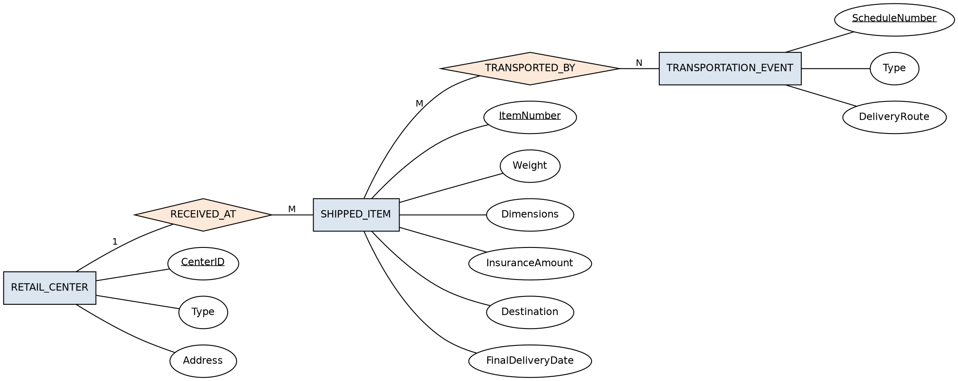
Figure 1: E-R diagram for the UPS Product Tracking System

Question 2 – Course Management System
Marks: 5 | Bloom's Level: BL2 – Understand
Question: A university database for scheduling classrooms for final exams could be modelled as a single entity set EXAM with attributes course-name, section-number, room-number, and time. Alternatively, additional entity sets could replace some of these attributes: COURSE (name, department, c-number), SECTION (s-number, enrollment) as a weak entity set dependent on Course, and ROOM (r-number, capacity, building). Show an E-R diagram illustrating the use of all three additional entity sets.
Answer:
Entities and Attributes
- COURSE (c-number (PK), name, department)
- SECTION (s-number (partial key), enrollment) — weak entity, existence-dependent on COURSE
- ROOM (r-number (PK), capacity, building)
Relationships
- COURSE SECTION_OF SECTION — identifying relationship, 1:M, with total participation of SECTION
- SECTION EXAM_IN ROOM — M:1, carries the attribute ‘time’ (the exam time for that section)
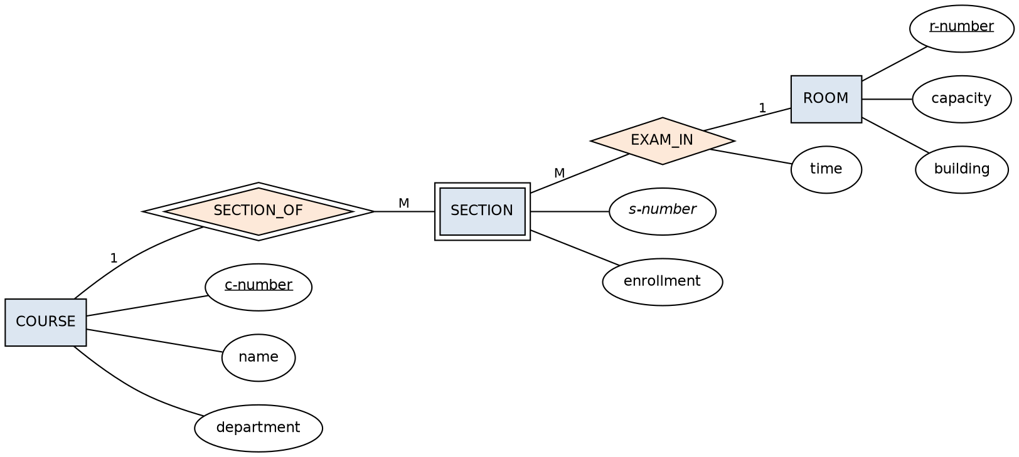
Figure 2: E-R diagram for the Course Management System

Question 3 – University Registrar’s Office Management System
Marks: 5 | Bloom's Level: BL2 – Understand
Question: A university registrar’s office maintains data about: (a) courses — number, title, credits, syllabus, and prerequisites; (b) course offerings — course number, year, semester, section number, instructor(s), timings, and classroom; (c) students — student-id, name, and program; (d) instructors — identification number, name, department, and title. The enrollment of students in courses and the grades awarded must also be modelled. Construct an E-R diagram for the registrar’s office.
Answer:
Entities and Attributes
- COURSE (course-number (PK), title, credits, syllabus)
- COURSE_OFFERING (section-number (partial key), year, semester, timings, classroom) — weak entity dependent on COURSE
- STUDENT (student-id (PK), name, program)
- INSTRUCTOR (instructor-id (PK), name, department, title)
Relationships
- COURSE HAS_OFFERING COURSE_OFFERING — identifying relationship, 1:M
- INSTRUCTOR TEACHES COURSE_OFFERING — M:N (an offering may have more than one instructor)
- STUDENT ENROLLS_IN COURSE_OFFERING — M:N, with the descriptive attribute Grade
- COURSE PREREQUISITE COURSE — recursive M:N relationship on the COURSE entity set
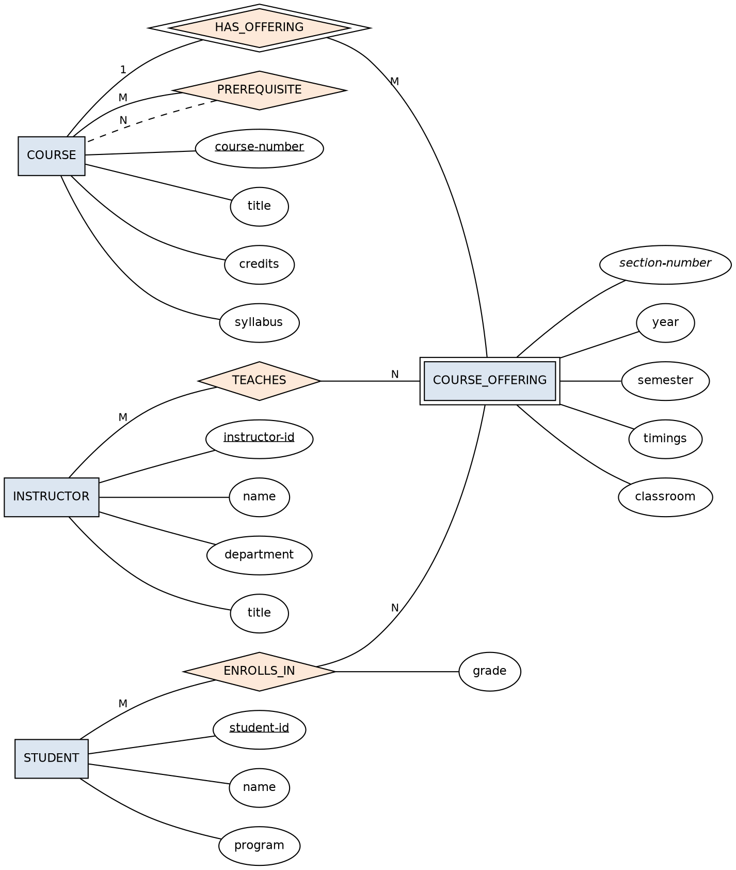
Figure 3: E-R diagram for the University Registrar’s Office

Question 4 – Hospital Management System
Marks: 5 | Bloom's Level: BL2 – Understand
Question: Construct an E-R diagram for a hospital with a set of patients and a set of medical doctors. Associate with each patient a log of the various tests and examinations conducted, and construct appropriate relational tables for the E-R diagram: Patient(SS#, name, insurance), Physician(name, specialization), Test-log(SS#, test-name, date, time), Doctor-patient(physician-name, SS#), Patient-history(SS#, test-name, date).
Answer:
Entities and Attributes
- PATIENT (SS# (PK), Name, Insurance)
- PHYSICIAN (Name (PK), Specialization)
- TEST (TestName (partial key), Date, Time) — weak entity, existence-dependent on PATIENT
Relationships
- PHYSICIAN TREATS PATIENT — M:N (a physician treats many patients, and a patient may be treated by several physicians)
- PATIENT UNDERGOES TEST — identifying relationship, 1:M
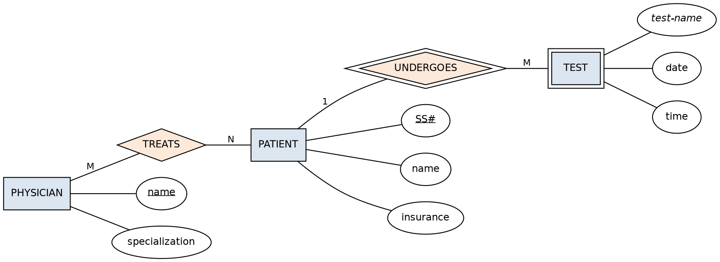
Figure 4: E-R diagram for the Hospital Management System
Relational Tables
Table | Attributes
Patient | SS# (PK), Name, Insurance
Physician | Name (PK), Specialization
Test_Log | SS# (FK → Patient), TestName, Date, Time
Doctor_Patient | PhysicianName (FK → Physician), SS# (FK → Patient)
Patient_History | SS# (FK → Patient), TestName, Date

Note: Doctor_Patient is the junction table that implements the M:N TREATS relationship between Physician and Patient; Test_Log and Patient_History both capture the log of tests, so in a normalised design they can be merged into a single table.

Question 5 – Company Project Management System
Marks: 5 | Bloom's Level: BL2 – Understand
Question: Construct an E-R diagram for a company with the following details. The company is organised into DEPARTMENTs, each with a unique name and a particular employee who manages it (the manager’s start date is recorded); a department may have several locations. A department controls a number of PROJECTs, each with a unique name, number, and a single location. Each EMPLOYEE has a name, ssno, address, salary, sex, and birth date; an employee is assigned to one department but may work on several projects (not necessarily controlled by that department), and the hours per week spent on each project is recorded, along with the employee’s immediate supervisor. Each employee’s DEPENDENTs are tracked for health-insurance purposes (dependent name, birth date, relationship to employee).
Answer:
Entities and Attributes
- DEPARTMENT (Dnumber (PK), Dname, Locations (multivalued))
- EMPLOYEE (Ssn (PK), Name, Address, Salary, Sex, Bdate)
- PROJECT (Pnumber (PK), Pname, Plocation)
- DEPENDENT (DependentName (partial key), BirthDate, Relationship) — weak entity, existence-dependent on EMPLOYEE
Relationships
- EMPLOYEE WORKS_FOR DEPARTMENT — M:1
- DEPARTMENT MANAGES (by) EMPLOYEE — 1:1, with attribute StartDate
- DEPARTMENT CONTROLS PROJECT — 1:M
- EMPLOYEE WORKS_ON PROJECT — M:N, with attribute Hours
- EMPLOYEE SUPERVISES EMPLOYEE — recursive 1:M
- EMPLOYEE DEPENDENTS_OF DEPENDENT — identifying relationship, 1:M
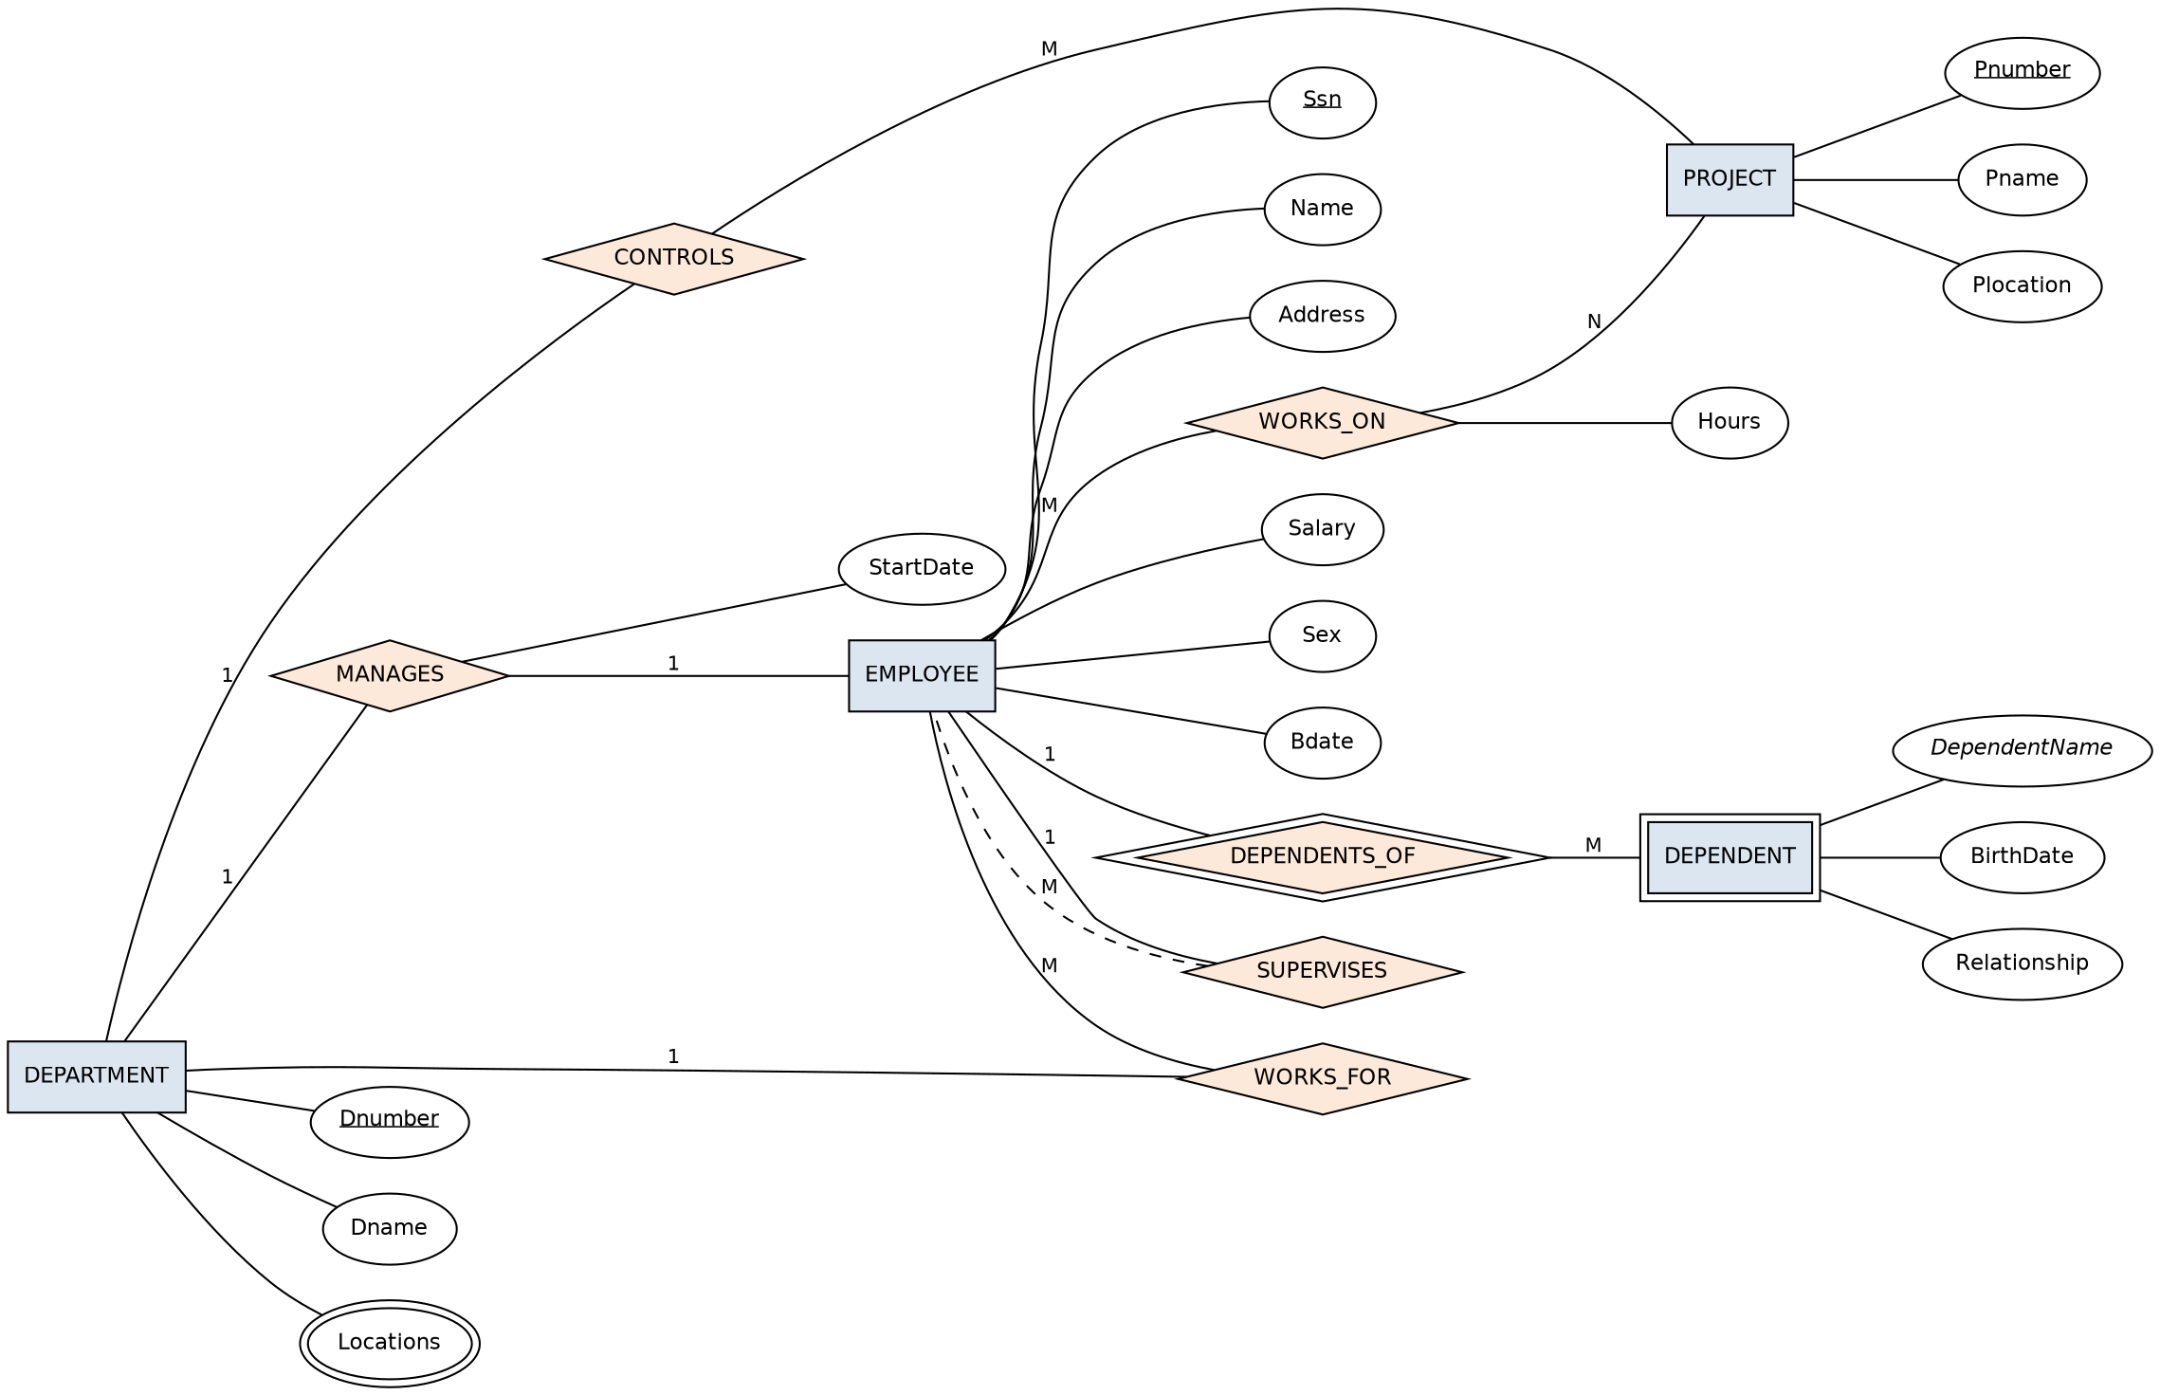
Figure 5: E-R diagram for the Company Project Management System

Question 6 – Schema, Instance, and Types of Schema
Marks: 5 | Bloom's Level: BL1 – Remember
Question: Explain schema and instance with examples. Distinguish between logical schema, physical schema, and view schema.
Answer:
Schema vs. Instance
- Schema: The overall design/structure of a database — the entities, attributes, and relationships — defined at the time the database is created and rarely changed. Example: Student(ID, Name, Department).
- Instance: The actual data stored in the database at a specific point in time; it changes every time data is inserted, updated, or deleted. Example: (101, Ravi, CSE).
Types of Schema (Three-Schema Architecture)
Schema Type | Description
Physical (Internal) Schema | Describes how data is actually stored — file organisation, indexes, and access paths.
Logical (Conceptual) Schema | Describes the overall structure for the whole database — tables, attributes, relationships, and constraints — independent of physical storage.
View (External) Schema | Describes the part of the database that a particular user or application is allowed to see.

Question 7 – Bank Management System
Marks: 5 | Bloom's Level: BL2 – Understand
Question: Identify the entities, attributes, and relationships for a Bank Management System and construct its E-R diagram.
Answer:
Entities and Attributes
- CUSTOMER (CustomerID (PK), Name, Address)
- ACCOUNT (AccountNo (PK), Type, Balance)
- BRANCH (BranchID (PK), Name, Address)
- LOAN (LoanNo (PK), Amount)
- EMPLOYEE (EmployeeID (PK), Name, Position)
Relationships
- CUSTOMER OWNS ACCOUNT — M:N
- BRANCH MAINTAINS ACCOUNT — 1:M
- CUSTOMER TAKES LOAN — M:N
- BRANCH OFFERS LOAN — 1:M
- EMPLOYEE WORKS_IN BRANCH — M:1
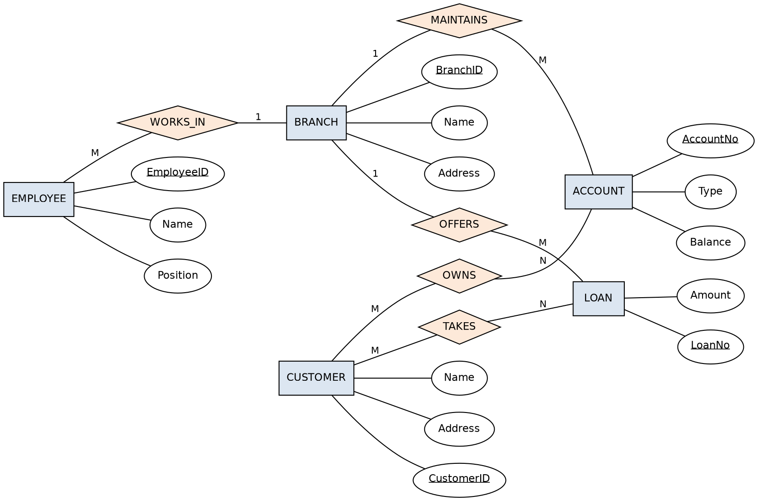
Figure 6: E-R diagram for the Bank Management System

Question 8 – Extended E-R (EER) Model
Marks: 5 | Bloom's Level: BL2 – Understand
Question: Explain the Extended E-R (EER) model. Describe the concepts of generalization, specialization, and aggregation.
Answer:
- Extended ER (EER) Model: An extension of the basic ER model that adds concepts such as class/subclass relationships and inheritance, so that it can model more complex applications more accurately.
- Generalization: A bottom-up process of combining several lower-level entity types that share common attributes into a single higher-level (generalized) entity type. Example: Car and Truck generalized into Vehicle.
- Specialization: A top-down process of dividing a higher-level entity type into two or more lower-level (specialized) subclasses, each with attributes or relationships specific to it. Example: Employee specialized into Engineer and Manager.
- Aggregation: A concept used to model a relationship as a higher-level entity type so that it can, in turn, participate in relationships with other entities. Example: the relationship between Employee, Project, and Manager can be aggregated so ‘works-on’ becomes an entity related to ‘manages’.

Question 9 – Hospital Management System (EER)
Marks: 5 | Bloom's Level: BL2 – Understand
Question: Design an EER diagram for a Hospital Management System incorporating inheritance and weak entities.
Answer:
Entities and Attributes
- PERSON (SSN (PK), Name) — superclass
- PATIENT (Insurance, AdmissionDate) — subclass of PERSON
- DOCTOR (Specialization, LicenseNo) — subclass of PERSON
- TEST_RECORD (TestName (partial key), Date) — weak entity, dependent on PATIENT
Relationships and Constraints
- PERSON is specialized (disjoint, ‘d’) into PATIENT and DOCTOR, which inherit SSN and Name from PERSON
- DOCTOR TREATS PATIENT — M:N
- PATIENT HAS TEST_RECORD — identifying relationship, 1:M
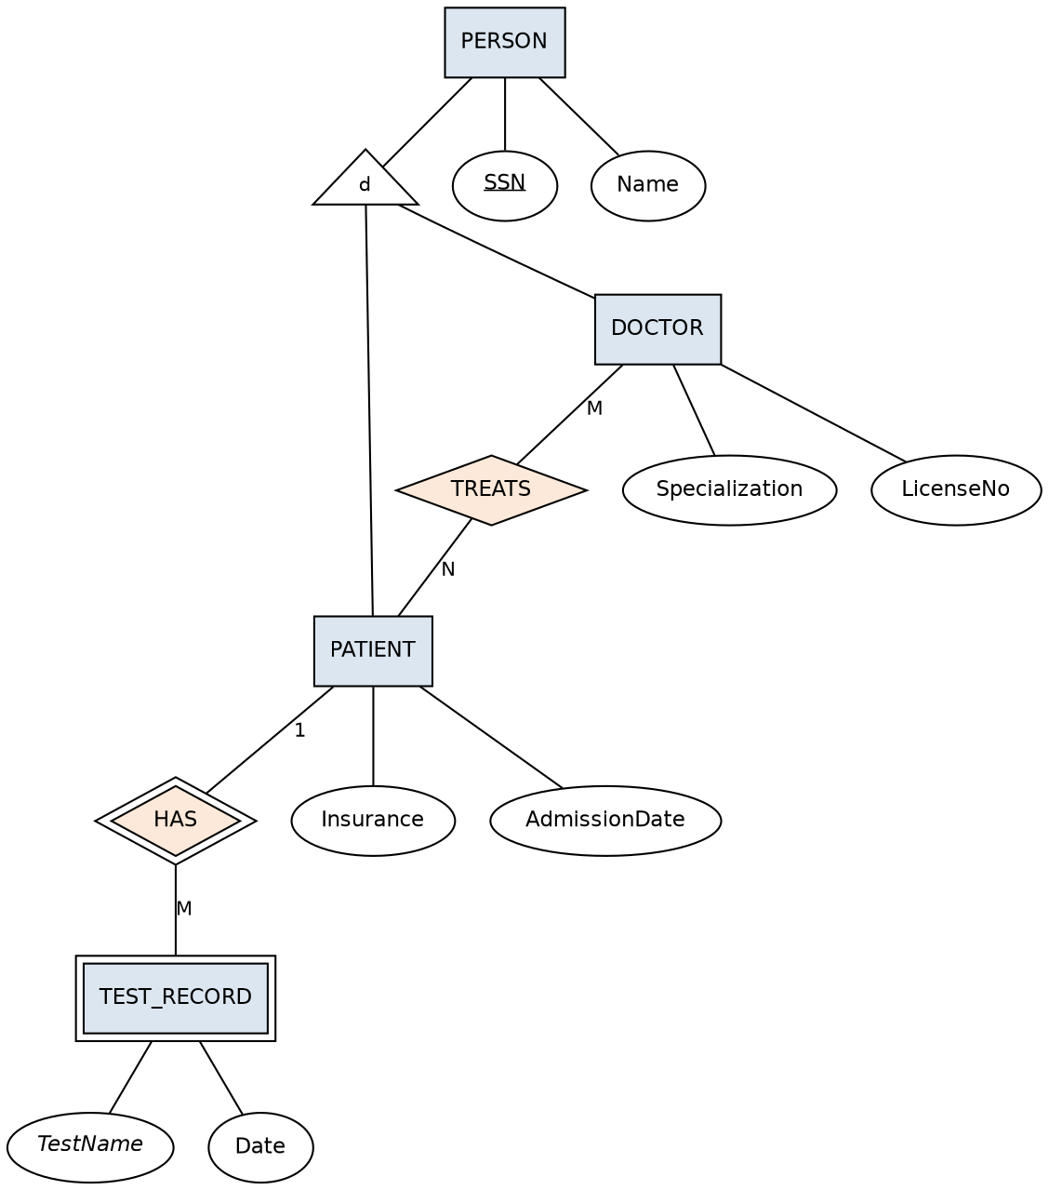
Figure 7: EER diagram for the Hospital Management System

Question 10 – Role of the Database Administrator (DBA)
Marks: 5 | Bloom's Level: BL1 – Remember
Question: Explain the role of a DBA (Database Administrator) and the responsibilities associated with the position.
Answer:
The DBA is the person (or team) responsible for the overall control, coordination, and management of the database system. Key responsibilities include:
- Installation and configuration: Installing and configuring the DBMS software.
- Schema and storage definition: Defining the database schema and physical storage structure.
- Security and authorization: Creating user accounts, granting/revoking access privileges, and enforcing authorization rules.
- Backup and recovery: Setting up regular backups and recovery procedures to protect against data loss.
- Performance tuning: Monitoring and optimizing queries, indexes, and system resources.
- Data integrity: Enforcing integrity constraints to keep the data accurate and consistent.
- Availability and maintenance: Monitoring database availability and routine maintenance tasks.
- Liaison with users: Coordinating with application developers and end users on data requirements.

